JSON Place holder API Testing Documentation Project
API Automation Testing using Rest Assured

Tools Used
- Java
- Maven
- JUnit 5
- Rest Assured
- IntelliJ IDEA

Base URL: https://jsonplaceholder.typicode.com
GitHub Link :

Project Structure

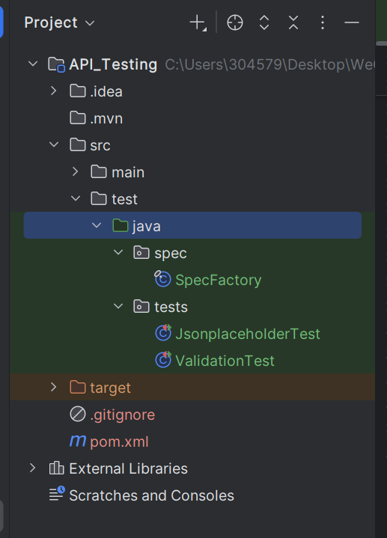

SpecFactory
Contains reusable Request Specification and Response Specifications.
- Base URI
- Headers
- Content Type
- Expected Status Codes

Test Class
Contains API test cases such as:
- Send a GET request to: /posts/1
- Validate:
  - Status Code = 200
  - Id = 1
  - userId is present
  - title is not empty
  - body is not empty
- Expectations:
  - Rest Assured
  - Status code validation
  - JSON Path
  - Assertions
- Validate Headers
- Validate Response Time

Test Scenarios
Test Case | Expected Result
Get | Status Code 200
Validate Response Time | Less than 5 seconds
Validate Headers | Content-Type should be JSON

Code:
SpecFactory.java
package spec;
import io.restassured.builder.RequestSpecBuilder;
import io.restassured.builder.ResponseSpecBuilder;
import io.restassured.http.ContentType;
import io.restassured.specification.RequestSpecification;
import io.restassured.specification.ResponseSpecification;
public final class SpecFactory {
private SpecFactory() {
}
public static RequestSpecification requestSpec() {
return new RequestSpecBuilder()
.setBaseUri("https://jsonplaceholder.typicode.com/")
.setContentType(ContentType.JSON)
.build();
}
public static ResponseSpecification success200() {
return new ResponseSpecBuilder()
.expectStatusCode(200)
.expectContentType(ContentType.JSON)
.build();
}
}
JsonplaceholderTest.java
package tests;
import io.restassured.response.Response;
import org.junit.jupiter.api.Test;
import spec.SpecFactory;
import static io.restassured.RestAssured.given;
import static org.junit.jupiter.api.Assertions.assertEquals;
import static org.junit.jupiter.api.Assertions.assertFalse;
import static org.junit.jupiter.api.Assertions.assertNotNull;
public class JsonplaceholderTest {
@Test
void getOne() {
Response response =
given()
.spec(SpecFactory.requestSpec())
.when()
.get("/posts/1");
response.then()
.spec(SpecFactory.success200());
assertEquals(200, response.getStatusCode(), "Status code should be 200");
int id = response.jsonPath().getInt("id");
Object userId = response.jsonPath().get("userId");
String title = response.jsonPath().getString("title");
String body = response.jsonPath().getString("body");
assertEquals(1, id, "id should be 1");
assertNotNull(userId, "userId should be present");
assertFalse(title == null || title.isBlank(), "title should not be empty");
assertFalse(body == null || body.isBlank(), "body should not be empty");
}
}
ValidationTest.java
package tests;
import io.restassured.response.Response;
import org.junit.jupiter.api.Test;
import spec.SpecFactory;
import static io.restassured.RestAssured.given;
import static org.junit.jupiter.api.Assertions.assertTrue;
public class ValidationTest {
@Test
void validateHeaders() {
Response response =
given()
.spec(SpecFactory.requestSpec())
.when()
.get("/posts");
response.then()
.spec(SpecFactory.success200());
assertTrue(
response.getHeader("Content-Type")
.contains("application/json"));
}
@Test
void validateResponseTime() {
Response response =
given()
.spec(SpecFactory.requestSpec())
.when()
.get("/posts/1");
assertTrue(response.time() < 5000);
}
}

Execution
Run all tests:
mvn clean test
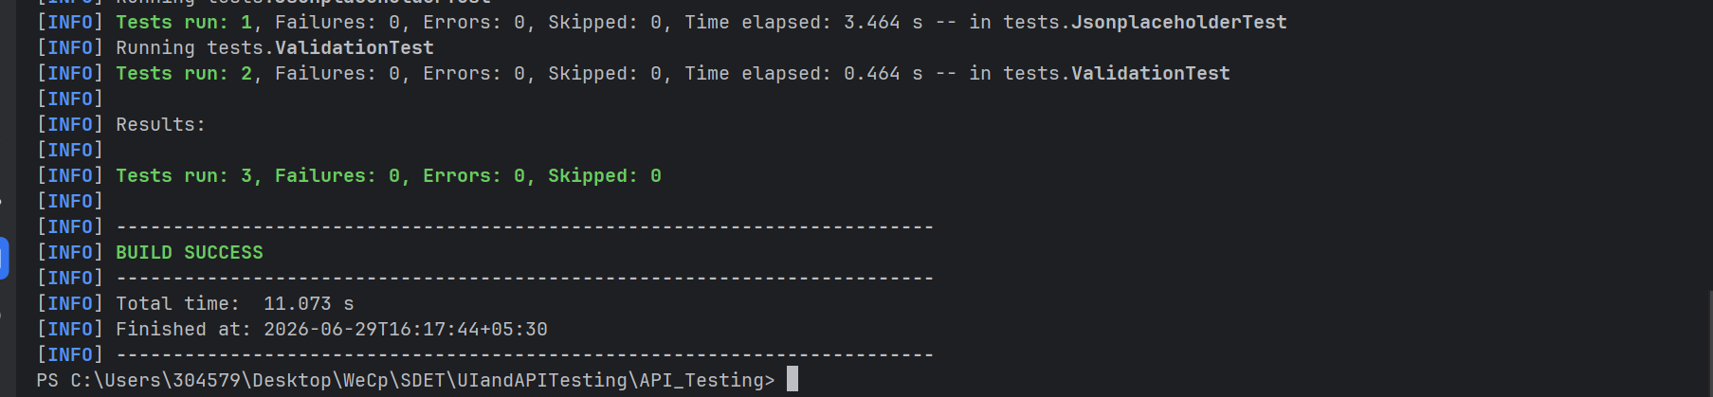

Run from IntelliJ:
• Right-click Run from IntelliJ • Click Run

- Get
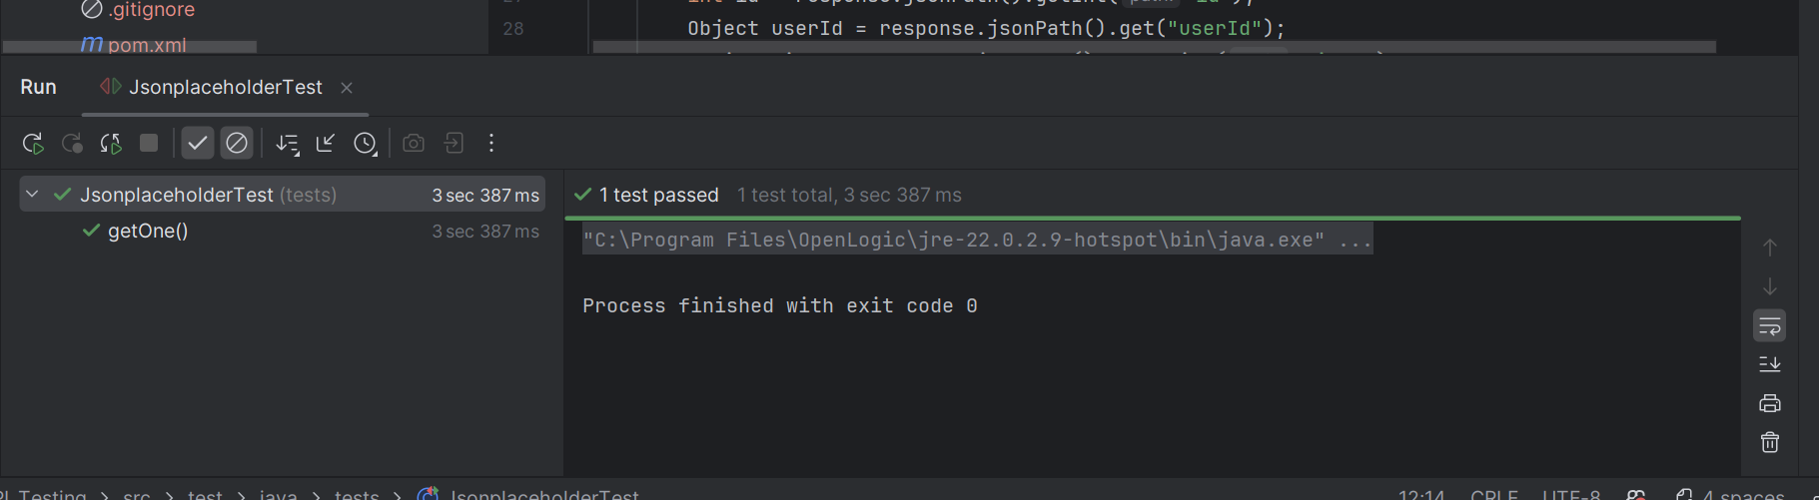

- Validate headers and response
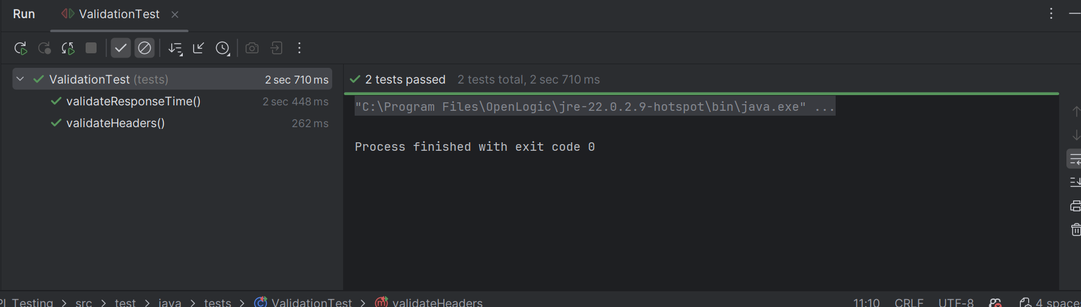

Conclusion
The project demonstrates the use of:
- Rest Assured
- Request Specification
- Response Specification
- JUnit 5 Assertions
- API Test Structure

